**Formulas**

**IF condition** :--🡪 =**IF(logical expression, ”Output if true”, ”Output if false”)**

**To get replicate in the entire column use dollar sign which is static throughout the whole column.**

**Eg🡪 =** 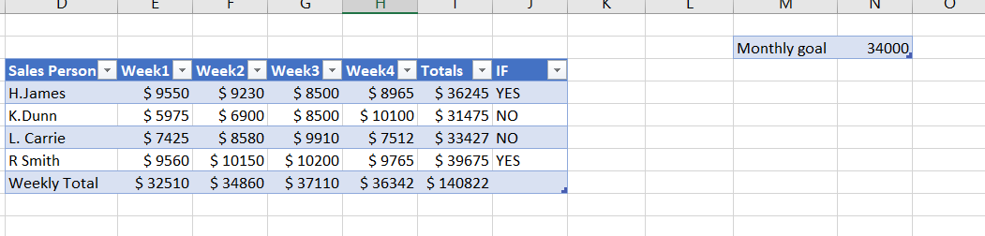

**Here we need to find if total salary is greater than monthly salary or not.**

**Thus monthly salary is static**

**So =IF(I4>=$N$3, ”YES”, “NO”) and drag throughout the whole column.**

**SUMIF**

**=sumif(rangeof first column,criteria,range of the output column)**

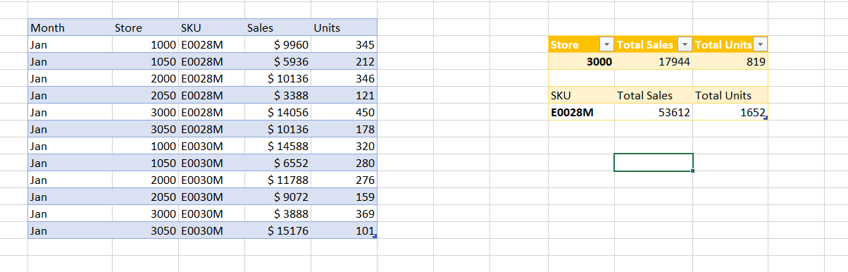

**VLOOKUP**

**It is used to drag the values of particular column from one sheet to another without copy paste.Time saved switching between sheets.**

**=vlookup(lookup_value, table array, col_index num, Rangelookup)**

**Watch window save lots of time in switching sheets just to get the information seen.This window keys an eye on the particular cells as needed.**

**Trace precedence gives the user an arrow type from how the value is calculated from where and what path.**

**Trace dependant tell which cells are dependant on the selected cell with an arrow heading from to the select cells.**

